NetBackup Role-Based Access Control (RBAC) Configuration for Bocada REST API Data Collection

# Add RBAC Role for Bocada Data Collection in NetBackup

1. Navigate to Security > RBAC:  
   Graphical user interface, application

   Description automatically generated
2. Add a *Custom* Role with a descriptive name:  
   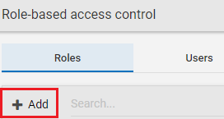  
   A picture containing logo

   Description automatically generated  
   Graphical user interface, text, application, chat or text message

   Description automatically generated
3. Assign Global Permissions: All available *View* for the following categories:
   * NetBackup management
   * Protection
   * Security (excluding certificate management)
   * Storage
4. Assigned a user to the new *Bocada Data Collection* role

# Add Permissions for the *Bocada*Role Add permissions for the *Bocada Data Collection* role for all relevant workloads for View and Discover

# API key (Optional)

Bocada can collect data with a user name and password of the user assigned to the *Bocada Data Collection* role. If using an API key is preferred then only one step remains.

Create an API key for the user assigned the *Bocada Data Collection* Role. Set the key so it does not expire for a long enough period to prevent collection failures in Bocada.

